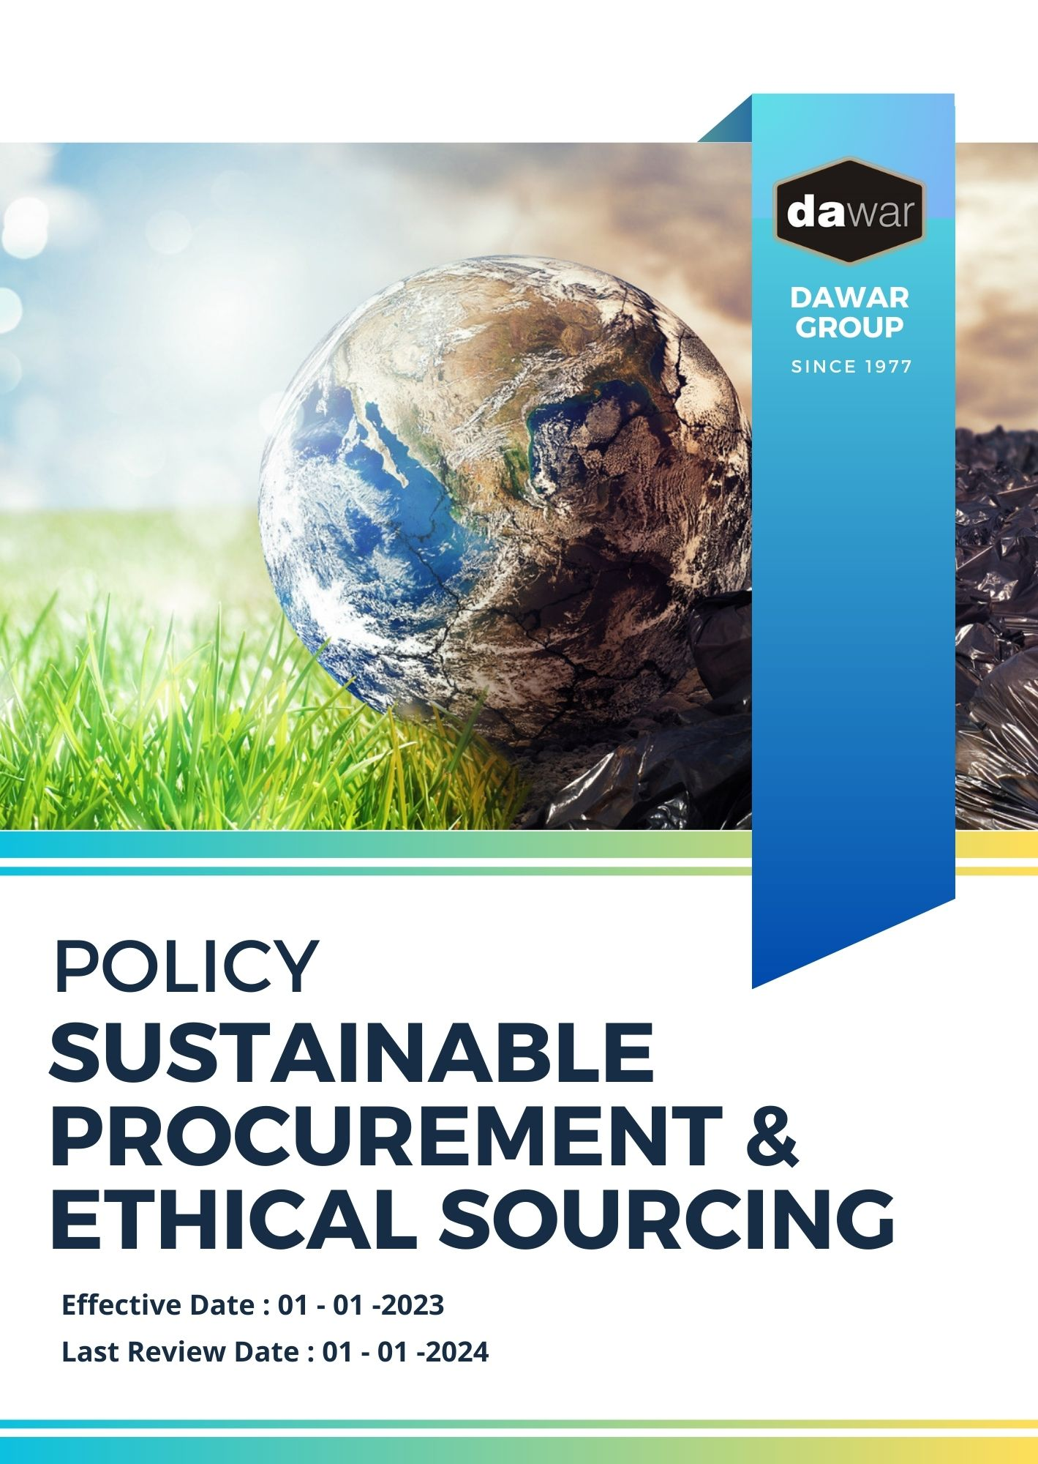

Table Of Contents

A. Why It Matters 3
B. The Dawar Group Way 3
C. Scope 3
D. What's Expected 3
E. Dawar Group's Commitment to Sustainable Procurement Excellence 4
F. Governance and Allocation of Responsibilities 5
G. Reporting Section 6
H. Covered SDGs 7
I. Review Mechanism 8
J. Employee Acknowledgement Form: Sustainable Procurement and Ethical Sourcing Policy 9

Why It Matters
At Dawar Group, we understand that adopting sustainable procurement practices is not only a responsibility but also a key driver of long-term success and resilience. Sustainable procurement is fundamental to minimizing our environmental footprint, ensuring ethical labor practices, and building robust supply chains that promote both social and environmental value. By embedding sustainability into our procurement processes, we align our operations with global sustainability standards, contributing positively to society while enhancing our business reputation.

The Dawar Group Way
Dawar Group is committed to embedding sustainable procurement principles across our entire supply chain. From sourcing to final product delivery, we strive to ensure that our practices reflect our commitment to environmental protection, ethical labor practices, and responsible sourcing. Our approach integrates sustainability into every procurement decision, focusing on transparency, ethical conduct, and long-term value creation.

We set annual sustainable procurement goals and ensure our teams have the necessary skills, resources, and support to achieve these targets. Innovation, continuous improvement, and collaboration with our supply chain partners are key to our sustainable procurement journey.

Scope
This policy applies to all employees, stakeholders, contractors, partners, customers, contractual workers, and anyone acting on behalf of following sites:

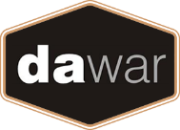 | Dawar Group
 | Address: Near Bapu Asaram Asaram, 12.5 Km, Agra-Delhi Road, Sikandra, Agra-282007 (India)
 | https://www.dawargroup.com/about-us/

What's Expected
- Sustainable Procurement Compliance
Dawar Group is committed to implementing sustainable procurement practices across our operations. We integrate environmental issues, such as reducing carbon emissions, minimizing waste, and promoting biodiversity, into our supply chain management alongside conventional procurement considerations like price, quality, and reliability. Additionally, we prioritize labor and human rights issues in supply chain management, ensuring fair wages, reasonable working hours, and safe working conditions for all workers involved in our supply chain. By going beyond legal compliance and actively embedding these sustainability considerations into all aspects of our procurement processes, we foster a culture of environmental responsibility and social equity.
We ensure continuous improvement in areas such as Responsible Sourcing and Supplier Engagement, Circular Economy and Waste Reduction, and Labor and Human Rights in the Supply Chain through:
- Evaluating suppliers not only on price, quality, and reliability but also on their environmental impact and adherence to fair labor standards.
- Establishing clear procedures for reporting sustainability concerns in the supply chain.
- Maintaining accurate records of our procurement practices and their environmental and social impacts.
- Implementing systems to track and reduce the carbon footprint of our procurement activities.
- Promoting the use of recycled and recyclable materials in our supply chain.
- Ensuring that all suppliers meet our standards for fair wages, working hours, and respect for human rights.

Dawar Group's Commitment to Sustainable Procurement Excellence
- Establishes 2022 as the Baseline year for measuring progress and achievements in our sustainability initiatives.

- Environmental Impact Reduction:
- Dawar Group is committed to minimizing the environmental footprint of its procurement activities by focusing on energy efficiency, waste reduction, and pollution control.
- We aim to reduce carbon emissions from our supply chain by 30% by 2026, through optimizing transportation, using low-carbon energy sources, and enhancing logistics efficiency.
- Dawar Group encourages the use of renewable energy and resource-efficient technologies throughout its supply chain.

- Ethical Sourcing and Supplier Development:
- Dawar Group works closely with suppliers to ensure they adhere to ethical sourcing practices, including responsible sourcing of raw materials and adherence to social and environmental standards.
- By 2026, we aim to implement a 100% comprehensive supplier training program that focuses on sustainability, human rights, and responsible sourcing practices.
- We are committed to conducting annual sustainability audits and performance reviews for all key suppliers.

- Sustainable Materials and Innovation:
- We plan to increase the use of sustainable, recycled, and biodegradable materials in our products and packaging by 50% by 2026.
- Dawar Group will invest in research and development to create innovative, eco-friendly products that reduce waste and resource consumption.
- By partnering with suppliers who specialize in sustainable materials, we will reduce the environmental impact of our products across their life cycle.

- Fair Labor Practices and Human Rights:
- Dawar Group is dedicated to upholding the highest standards of labor practices across its supply chain, ensuring fair wages, reasonable working hours, and safe working conditions.
- We aim to 100% eliminate forced labor, child labor, and exploitative working conditions throughout our supply chain by 2026, through rigorous supplier screening and audits.
- Our commitment includes ensuring that all workers involved in our supply chain are treated with dignity and respect, with access to grievance mechanisms.

Governance and Allocation of Responsibilities
The governance structure at Dawar Group for the Sustainable Procurement and Ethical Sourcing Policy ensures clear allocation of responsibilities, driving accountability and continuous progress towards our sustainability objectives. Key governance roles include:
- Board of Directors:
- Oversees the overall sustainable procurement strategy and approves long-term goals related to ethical sourcing and environmental impact reduction.
- Ensures alignment of procurement practices with business objectives, environmental sustainability goals, and stakeholder expectations.

- Chief Procurement Officer (CPO):
- Implements and manages the Sustainable Procurement and Ethical Sourcing Policy.
- Reports on supply chain sustainability performance, including labor rights, human rights, and environmental metrics.

- Sustainability Committee:
- Oversees day-to-day operations concerning sustainable procurement and compliance.
- Coordinates with procurement, legal, and sustainability departments to integrate ethical and sustainable practices into procurement activities.

- All Suppliers:
- Adhere to Dawar Group’s sustainable procurement guidelines.
- Participate in regular audits and assessments to ensure compliance with labor, human rights, and environmental standards.

- All Employees:
- Comply with the Sustainable Procurement and Ethical Sourcing Policy and attend related training.
- Report any violations related to environmental issues, labor rights, or human rights to the Sustainability Team.

Reporting Section
At Dawar Group, transparent and structured reporting is key to ensuring that our sustainable procurement practices are effectively communicated to stakeholders, including employees, suppliers, customers, and regulatory bodies. The following outlines our reporting framework:

- Sustainable Procurement Metrics:
- Conduct annual evaluations of key performance indicators (KPIs) such as supplier compliance with labor standards, environmental impact reductions, and sustainable material usage.
- Utilize supplier scorecards and tracking systems to monitor compliance and ensure real-time data collection.
- Prepare and review quarterly reports comparing supplier performance against established sustainability goals and procurement standards.

- Annual Sustainable Procurement Report:
- Publish a detailed annual report summarizing procurement activities, supplier audits, environmental achievements, and challenges.
- Highlight initiatives such as the transition to sustainable materials and improvements in supplier working conditions.
- Engage independent third-party auditors to verify compliance and accuracy of sustainability reports, ensuring credibility and transparency.

- Supplier Incident Reporting:
- Implement a robust system for reporting and addressing violations of environmental, labor, or human rights standards within the supply chain.
- Provide monthly summaries of incidents, including root cause analysis and corrective actions to prevent future violations.

- Community and Stakeholder Engagement Reports:
- Document our efforts in promoting sustainability across the supply chain, including stakeholder consultations and supplier engagement initiatives.
- Gather feedback from stakeholders regarding the effectiveness of our sustainable procurement practices and use this feedback for continuous improvement.

Covered SDGs
 |  |  |  | 

Review Mechanism

The Sustainability Committee is responsible for overseeing the implementation and regular review of this Sustainable Procurement and Ethical Sourcing Policy. This policy will be reviewed annually to ensure its continued effectiveness and alignment with emerging sustainability standards and business needs. Updates and amendments will be communicated to all stakeholders, including suppliers and employees, as necessary to ensure transparency and compliance.

(Signature)
Approved By:
Designations:
Next Review Date: 01-01-2025

Employee Acknowledgement Form: Sustainable Procurement and Ethical Sourcing Policy

I, acknowledge that I have received, read, and understood Dawar Group's Sustainable Procurement and Ethical Sourcing Policy. I am aware of the company's commitment to promoting sustainable and ethical procurement practices across the entire supply chain, including environmental sustainability, labor rights, and human rights.
I understand my role in supporting this policy by complying with all applicable procurement guidelines and sustainability initiatives. This includes adhering to responsible sourcing practices, ensuring supplier compliance with ethical standards, and actively contributing to Dawar Group's sustainability objectives.
By signing below, I confirm my commitment to upholding Dawar Group's Sustainable Procurement and Ethical Sourcing Policy and supporting the company's efforts toward sustainable procurement excellence.
Employee Name: ______________________
Employee Signature: ______________________
Date: __________________

